**Step**

**(PC)Connect**

Command line: Server NodeJS Socket.io Started..

**(Android)Worker1 Send connect request to server**

SND_CNT:{ name:”Worker”}

Console log: Request to connect..

**(PC)Server Nodejs receive connect request from client and return message receive**

Command line: Worker 1(192.168.0.1) 's connected

REQ_CNT:{id: 1, name:”Worker1”,ip: ” 192.168.0.1”, numClient : 0, nameWorker : 1 }

**(Android)Worker1 Receive connected request to server**

Console log: Connected..

**(Android)Worker2 Send connect request to server**

SND_CNT:{ name:”Worker”}

Console log: Request to connect..

**(PC)Server Nodejs receive connect request from client and return message receive**

Command line: Worker 2(192.168.0.2) 's connected

REQ_CNT:{ id: 2, name:”Worker2”,ip: ”192.168.0.2”, numClient : 0, nameWorker : 2 }

**(Android)Worker2 Receive connected request to server**

Console log: Connected..

**(Android)Client1 Send connect request to server**

SND_CNT:{ name:”Worker”}

Console log: Request to connect..

**(PC)Server Nodejs receive connect request from client and return message receive**

Command line: Client1(192.168.0.3) 's connected

REQ_CNT:{ id: 1, name:”Client1”,ip: ”192.168.0.3”, numClient : 1, nameWorker : 2 }

**(Android)Client1 Receive connected request to server**

Console log: Connected..

Tab 1 Display: Worker Connected status

**(Android)Client1 Send request to server**

SND_REQ:{img_name:"pic1",img_data: bitmap data, process_gs: 1, process_bf: 1, process_gb: 1}

Console log: Sent work to server, id: 1, name: Client1, img_name:"pic1", process_gs: 1, process_bf: 1, process_gb: 1

**(PC)Server Nodejs received request from client and Send task to worker1, worker2**

Command line: Received work from client1, id: 1, img_name:"pic1", process_gs: 1, process_bf: 1, process_gb: 1

REC_TASK: {sort_id: 1, worker_id: 1, name:”Worker1” , img_data: bitmap data, img_name:"pic1", task: “gs”}

Command line: Sent task to Worker1, sort_id: 1, worker_id: 1 , img_name:"pic1", task: “gs”

REC_TASK: { sort_id: 1, worker_id: 2, name:”Worker2” , img_name:"pic1"", task: “bf”}

Command line: Sent task to Worker2, sort_id: 1, worker_id: 2 , img_name:"pic1", task: “bf”

**(Android)Worker1 received work from server and return result task to server**

Console log: Received task from server : sort_id: 1, worker_id: 1, name:”Worker1” , img_name:"pic1", task: “gs”

SND_TASK_RS: { sort_id: 1, worker_id: 1, name:”Worker1” , img_data: bitmap data, img_name:"pic1"", task: “gb”}

Console log: Send result task to server, sort_id: 1, worker_id: 1, name:”Worker1” , img_name:"pic1", task: “gb”

**(Android)Worker2 received work from server and return result task to server**

Console log: Received task from server , sort_id: 1, worker_id: 2, name:”Worker2” , img_name:"pic1", task: “gs”

SND_TASK_RS: { sort_id: 1, worker_id: 2, name:”Worker2” , img_data: bitmap data, img_name:"pic1"", task: “bf”}

Console log: Send result task to server , sort_id: 1, worker_id: 2, name:”Worker2” , img_name:"pic1", task: “bf”

**(PC)Server Nodejs received task from worker1**

Command line: Received task from worker1, sort_id: 1, worker_id: 1, img_name:"pic1"", task: “gs”

**(PC)Server Nodejs received task from worker2**

Command line: Received task from worker2, sort_id: 1, worker_id: 2, img_name:"pic1"", task: “bf”

**(PC)Server Send task to worker1**

REC_TASK: {sort_id: 1, worker_id: 1, name:”Worker1” , img_data: bitmap data, img_name:"pic1", task: “gb”}

Command line: Sent task to Worker1, sort_id: 1, worker_id: 1, name:”Worker1” , img_data: bitmap data, img_name:"pic1", task: “gb”

**(Android)Worker1 received work from server and return result task to server**

Console log: Receive task from server , sort_id: 1, worker_id: 1, name:”Worker1” , img_data: bitmap data, img_name:"pic1", task: “gb”

SND_TASK_RS: { sort_id: 1, worker_id: 1, name:”Worker2” , img_data: bitmap data, img_name:"pic1", task: “gb”}

Console log: Send result task to server , sort_id: 1, worker_id: 2, name:”Worker2” , img_data: bitmap data, img_name:"pic1", task: “gb”

**(PC)Server Nodejs received task from worker1**

Command line: Received task from worker1, sort_id: 1, worker_id: 1, img_name:"pic1", task: “gb”

**(PC)Server Nodejs sent result work to client**

REC_TASK_RS: { id: 1, name:”Client1”, worker_id: 1, worker_name:”Worker1”, img_data: bitmap data, img_name:"pic1"", task: “gs”}

Command line: Sent result work to client1, id: 1, worker_id: 1, worker_name:”Worker1” , img_data: bitmap data, img_name:"pic1"", task: “gs”

REC_TASK_RS: { id: 1, name:”Client1”, worker_id: 2, worker_name:”Worker2”, img_data: bitmap data, img_name:"pic1"", task: “bf”}

Command line: Sent result work to client1, id: 1, worker_id: 2, worker_name:”Worker2” , img_data: bitmap data, img_name:"pic1"", task: “bf”

REC_TASK_RS: { id: 1, name:”Client1”, worker_id: 1, worker_name:”Worker1”, img_data: bitmap data, img_name:"pic1"", task: “gb”}

Command line: Sent result work to client1, id: 1, worker_id: 1, worker_name:”Worker1” , img_data: bitmap data, img_name:"pic1"", task: “gb”

**(Android)Client1 received work from server**

Command line: received work from server, id: 1, worker_id: 1, worker_name:”Worker1” , img_data: bitmap data, img_name:"pic1"", task: “gs”

Command line: received work from server, id: 1, worker_id: 2, worker_name:”Worker2” , img_data: bitmap data, img_name:"pic1"", task: “bf”

Command line: received work from server, id: 1, worker_id: 1, worker_name:”Worker1” , img_data: bitmap data, img_name:"pic1"", task: “gb”

Tab 1 Display: Result Worked

**Node Server file**

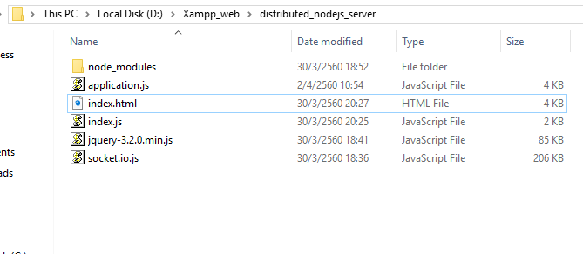

**Run Server Script & Client Script**

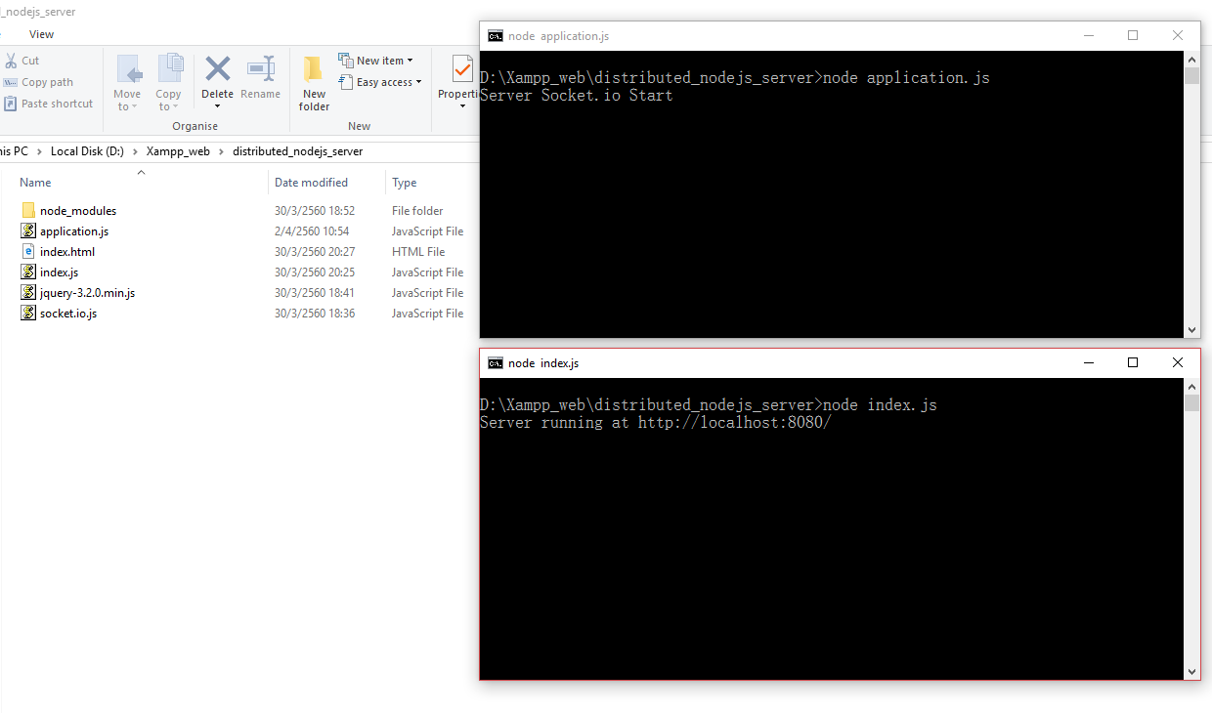

**Server Command Line**

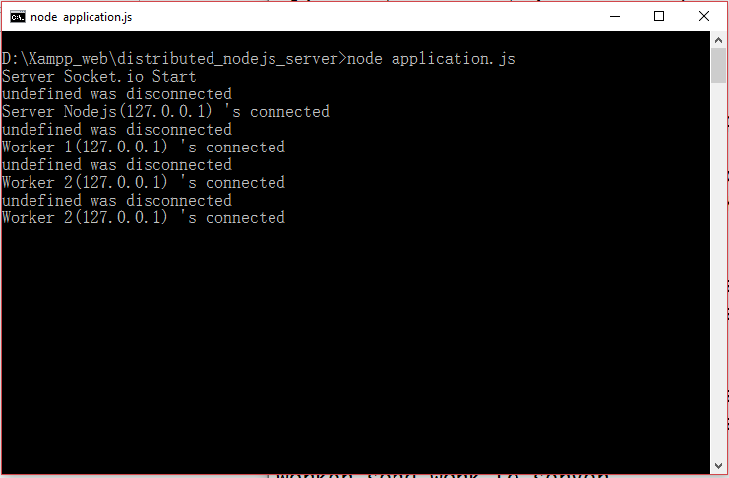

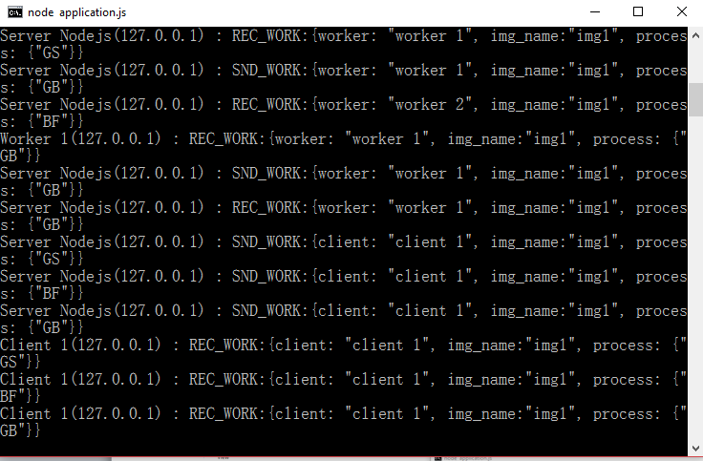

**Command Line**

**…**

**Browser Message Box of worker for Web Testing**

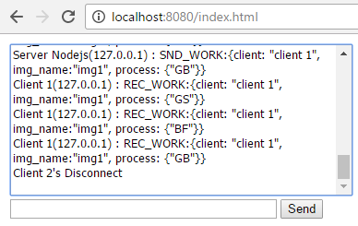

**(Android)Worker Console log**

Worker 1

…

Worker 2

…

**(Android)Client Message Line**

...